**Assignment 01**

**Game Development Lab**



**Fall 2024**

Name : **AWAIS SADDIQUI**

Reg # : **21PWCSE 1993**

Section: **“A”**

Submitted To:

**Abdullah Hamid Sir**

**Computer Systems Engineering, University of Engineering and Technology Peshawar.**

**Question 01:**

Download free assets/packages from Unity Asset Store and import them to a project and use them in a scene.

**Step # 01:**

Go to the webpage of Unity Asset Store. <https://assetstore.unity.com/>

**Step # 02:**  
Click on 3D and then select the characters. For free assets checked the “**Free Asset** “on the sidebar.

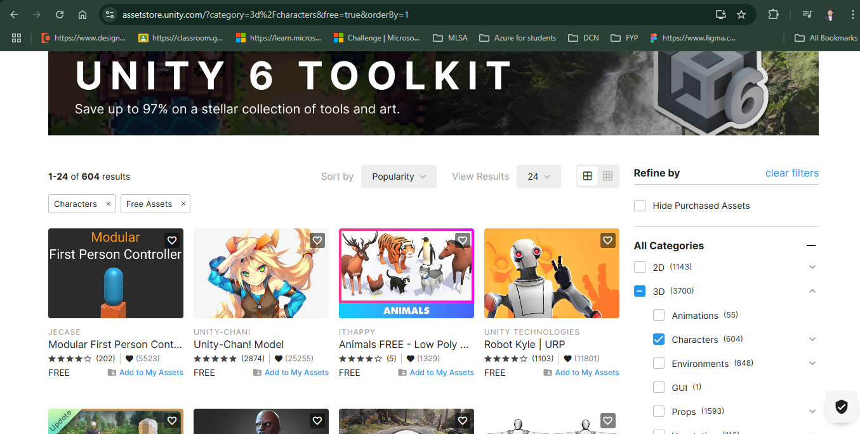

**Step # 03:**  
Click on the Add to My Assets.

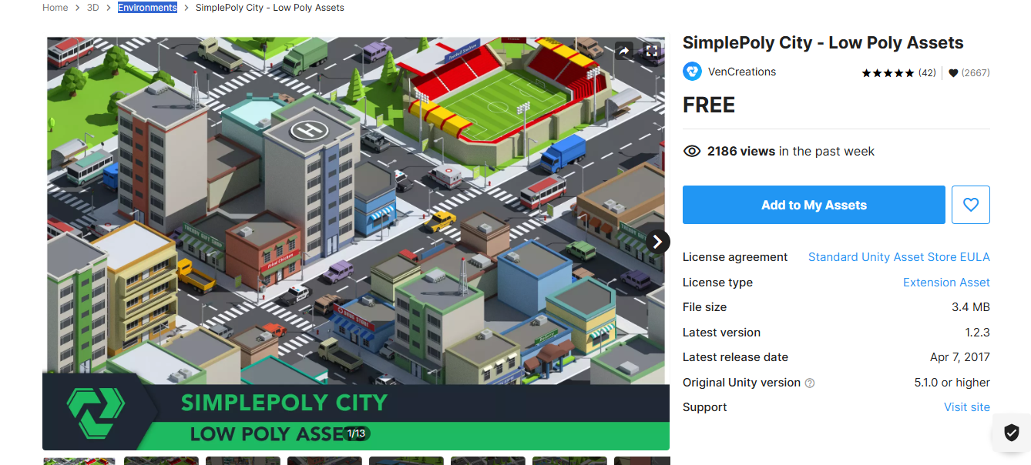

**Step # 04:**  
Navigate to My Assets and click on the Open in Unity .

**Step # 05:**  
Click on the download button to Download a package . After downloading click on the import .

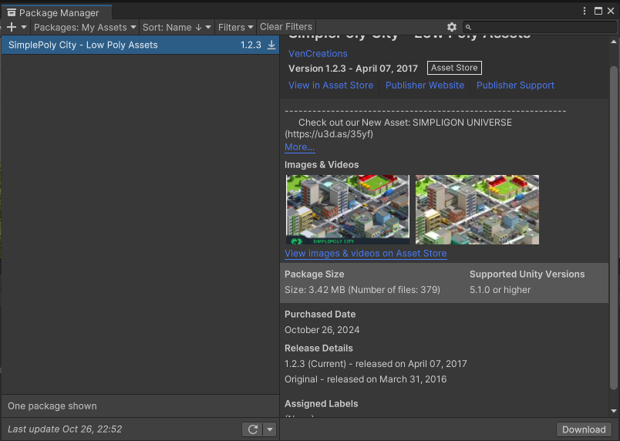

**Step 06:**  
Use the Assets/ package .  
